## Trial tutorial of Intelligent Windmill

1. **Burn the code**

The trial code is placed in the 2.2 trial tutorial folder.

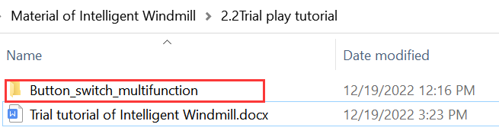

1. **Open the code, and use the data cable to connect the main board interface of Intelligent Windmill and USB interface of computer.**

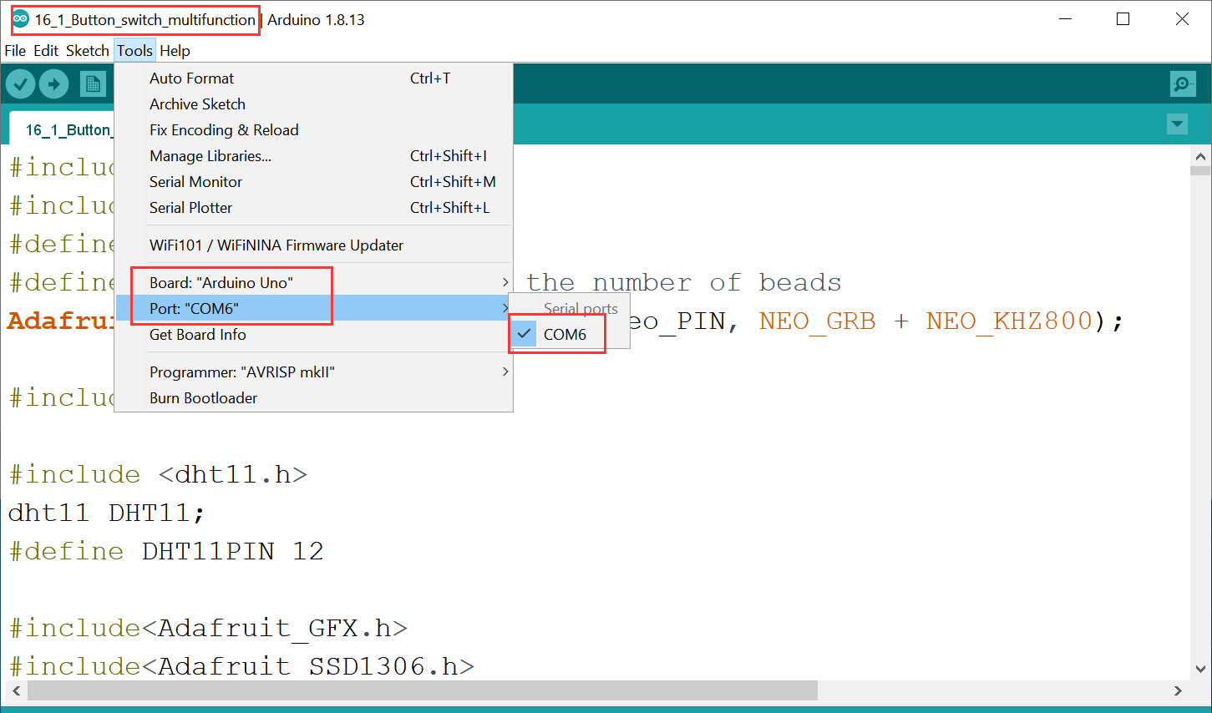

1. **Burn the trial code**

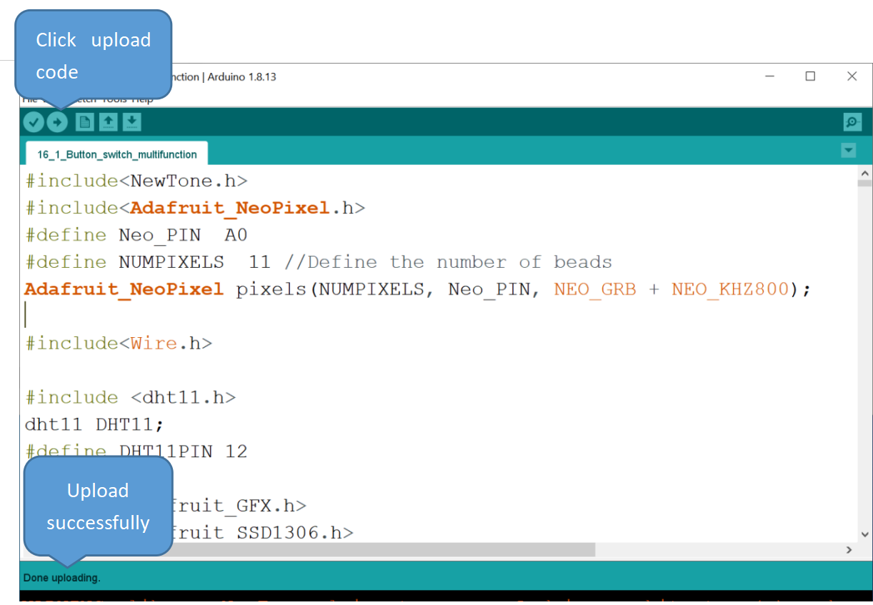

1. **Trial steps**

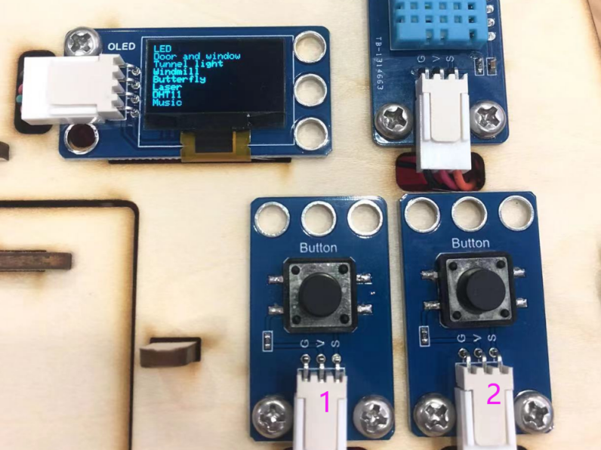

1. **Easy trial steps**

* The OLED screen displays the names of 8 functions.
* Click button 1 slowly to select the function.
* Double click button 1 quickly to enter the function, and the screen will display the operation method of the corresponding function.
* Press and hold button 1 and then press button 2 to exit the current function.

1. **Detailed trial operation steps**
2. **LED**

Click button 1 slowly to choose the LED function. The “^”in front of “LED”means that it is selected, as shown below.

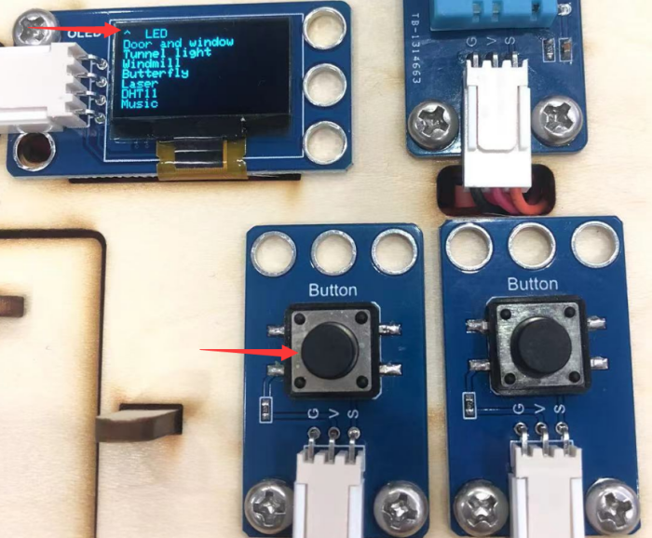

Double click button 1 quickly to enter the function of controlling the LED. Click button 2 once, and LED comes on. Click button 1 once, and LED is off.

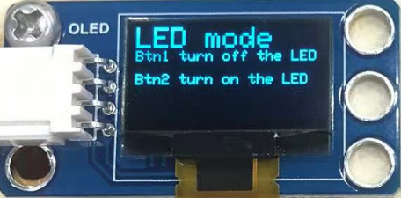

**Press and hold button 1, and click button 2 immediately, the current function will be exited.**

1. **Door and window**

Click button 1 slowly to choose Door and window function.

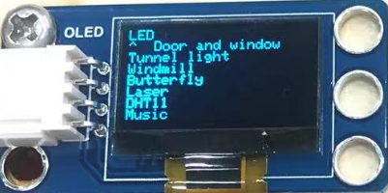

Double click button 1 quickly to enter the function of controlling door and window. Click button 2 once, and the door and window open. Click button 2 again, they close.

**Press and hold button 1, and click button 2 immediately, the current function will be exited.**

1. **Tunnel light**

Click button 1 slowly to choose Tunnel light function.

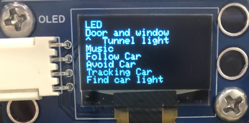

Double click button 1 quickly to enter the function of controlling tunnel light. Then click button 2 to change the color of it, as shown below.

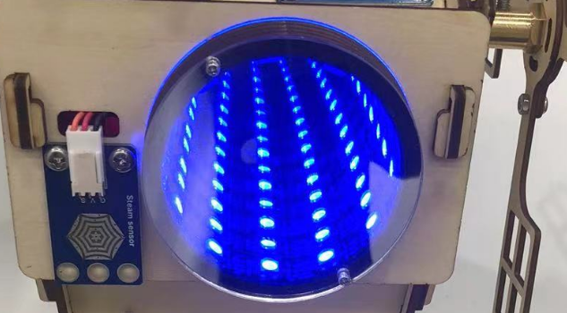

**Press and hold button 1, and click button 2 immediately, the current function will be exited.**

1. **Windmill**

Click button 1 slowly to choose windmill function.

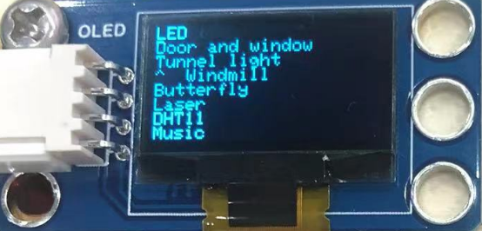

Double click button 1 quickly to enter windmill function. Then click button 2 to turn the windmill, and click button 1 to stop the windmill.

**Press and hold button 1, and click button 2 immediately, the current function will be exited.**

1. **Butterfly**

Click button 2 slowly to select butterfly function,as shown below.

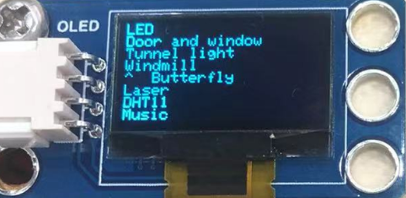

Double click button 1 to enter the butterfly function, then click button 2, the butterfly will flutter its wings. Click button 1 to stop the butterfly.

**Press and hold button 1, and click button 2 immediately, the current function will be exited.**

1. **Laser**

Laser projection function

Click button 1 slowly to select laser function.

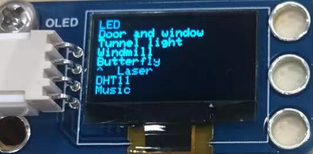

Double click button 1 quickly to enter laser function. Click button 2 to turn on the laser,and then turn the DOE to switch the projected pattern.

|  |  |  |  |  |  |
| --- | --- | --- | --- | --- | --- |
| Rotate the DOE | |  | |  | |
|  |  | |  | |  |

**Press and hold button 1, and click button 2 immediately, the current function will be exited.**

1. **DHT11**

DHT11 temperature and humidity meter

Click button 1 slowly to select DHT11.

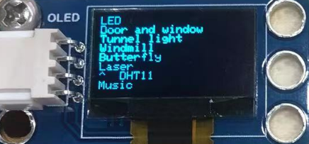

Double click button 1 to enter the DHT11 function, and then click button 2 to display the temperature and humidity values on the OLED screen.

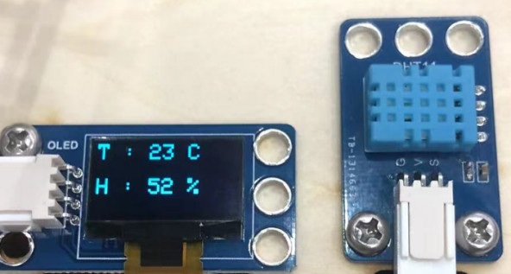

**Press and hold button 1, and click button 2 immediately, the current function will be exited.**

1. **Music**

The buzzer plays Happy Birthday.

Click button 1 slowly to select Music function.

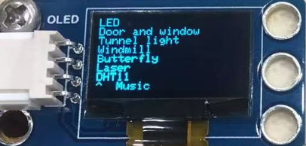

Then double click button 1 to enter the Music function, and click button 2 once to play Happy Birthday.

**Press and hold button 1, and click button 2 immediately, the current function will be exited.**